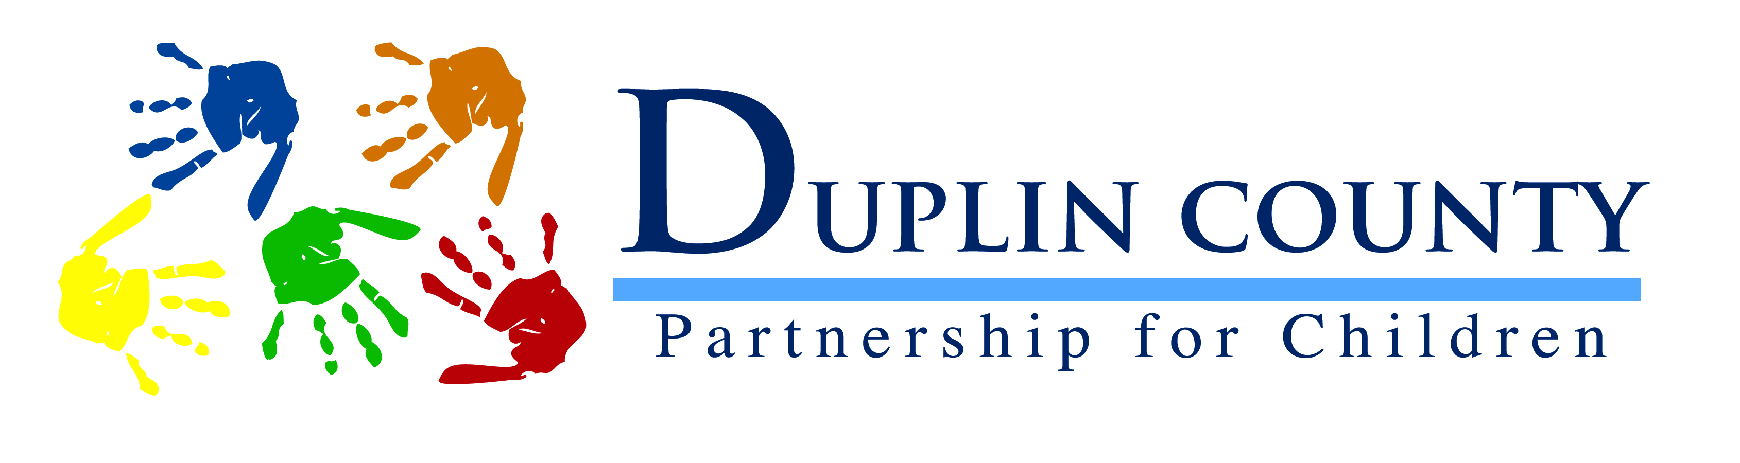
Training Registration Form
Please print clearly
Title of Workshop: ____________________________________________________________________
Date of Workshop: ____________________________________________________________________
Name of Center or Home: ______________________________________________________________
Facility Number: _________________________
Name(s) of Participant(s) | Daytime Phone | Evening Phone
If you have more than 10 participants, please complete additional form(s)

Cost of workshop per participant: $__________ Total amount sent: $__________

Please mail checks to: Duplin County Partnership for Children
PO 989
Kenansville, NC 28349

NO PERSONAL CHECKS WILL BE ACCEPTED ONLY CASHIER CHECKS OR MONEY ORDERS!
Registrations that are mailed after the deadline will only be accepted if there is space available. No registrations will be accepted within 24 hours of a workshop. You are not considered registered until we receive your completed form(s) and payment. We will call you to confirm that all documents have been received.
- Make copies of this form for future use
- Please call Karen Pacheco at (910) 296-2000 with any questions.

