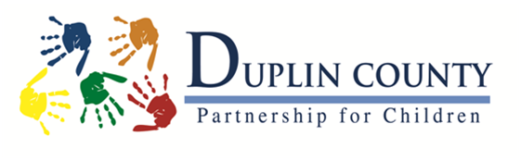
Please mail to:
Duplin County Partnership for Children
Post Office Box 989
1st
Kenansville, NC 28349

Please return by: June 4, 2022

Tournament: June 9, 2022 at Duplin Country Club Registration: 8:30 AM
Kenansville, NC 28349

Company Name: ________________________________________________________
Contact Name: _______________________________________________________________
Contact E-Mail: ______________________________________________________________
Contact Phone Number: _______________________________________________________
Mailing Address: ______________________________________________________________
Physical Address: (if different above): _____________________________________________
City, State, Zip: _______________________________________________________________
Sponsorship Levels Team Entry

__________ Scoreboard Sponsor: $1000.00
(includes up to 2 teams and name on scoreboard)
__________ Beverage Cart Sponsor: $400.00
(includes sign and ad on beverage cart)
__________ Gift Bag Sponsor: $500.00 (includes sign and ad in gift bag)
__________ Team Sponsor: $300.00 (includes a team of 4 entry fee)
__________ Hole Sponsor: $200.00
(includes sign with company or individual information)
Total: $__________

Team Member’s Names & Handicap (please include email address and contact number)

Team Name: ______________________________________________________

Player 1: ______________________________________________________Handicap: ______
Player 2: ______________________________________________________Handicap: ______
Player 3: ______________________________________________________Handicap: ______
Player 4: ______________________________________________________Handicap: ______

Please make checks payable to: Duplin County Partnership for Children
PO Box 989, Kenansville NC 28349
For more information, call Karen Pacheco at 910-296-2000.

